Air Fryer Chicken Wings

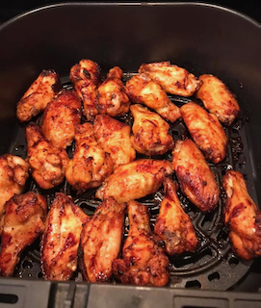

Ingredients

* Chicken wings 1 lb
* Honey Garlic Sauce ½ cup
* Paprika or chili powder 1 tsp
* Baking powder ½ tsp
* Black pepper powder 1 tsp
* Salt as needed.

Method

Marinate wings with all the ingredients listed. Refrigerate for an hour or so.

Turn on air fryer to air fry mode for 380 ° F set to 20 minutes. When preheated, spray some cooking spray to the basket. Place the wings into the basket without crowding them and cook. Flip sides when prompted and cook till it’s done. Enjoy with your favorite dip.